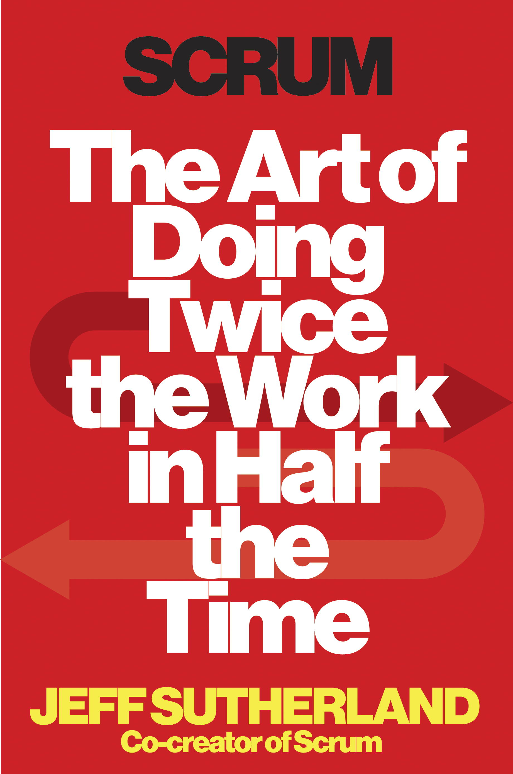

Let’s ask a question that has a chance to actually change things: “What is the set of incentives that drives bad behavior?” I truly doubt that any of the Beltway bandits sees themselves as bad people, and I’d bet that most are truly well-meaning. It’s the *system* that has failed them, and us. But how do we change it? How do we encourage transparency, priori- ties, and accountability? You know the answer: Scrum.

Let’s start a few thousand miles west of Washington, D.C., in the Washington state capital, Olympia. There, the past two administrations—first a Republican, now a Democrat—have embraced what they call Lean government. The current governor, Jay Inslee, said in a campaign interview in the fall of 2012, “A lot of what the state does is make decisions. We want to find a way to leave less paper on a desk.”1

The governor’s plan has five points that could have been plucked from any campaign platform:

1. A “world-class” education system from preschool through college;

2. A “prosperous economy”;

3. Making Washington a national leader in sustainable energy and a clean environment;

4. Healthy and safe communities;

5. Efficient, effective, and accountable government.

These are not revolutionary goals. This is what people *should* expect from their government. The very fact that they sound clichéd is an indicator of their importance. A cliché, after all, is just a truth repeated enough times to become trite. But what’s *different* about Inslee’s administration is how they’re going about it. They’ve dubbed their new approach SMART—Specific, Measureable, Attainable, Relevant, and Time-bound. In other words, they want to use Scrum. And, in fact, they are.

The office of the Chief Information Officer of the State of Washington is responsible not only for what technology is purchased, but how it’s made. The CIO’s office is made up of twenty people who are supposed to make sure massive IT failures, costing tens of millions of dollars, don’t happen. Meanwhile, the department handles IT upgrades for the parts of the government that do everything from issue driver’s licenses, to distribute unemployment benefits, to regulate fish and wildlife. In 2012 they oversaw eighty requests totaling more than $400 million. And they issue standards and guidance to various agencies on how to implement state policy.

To do that, they use Scrum. They’ve actually torn down the cubicle walls in their offices and formed into Scrum teams.

Michael DeAngelo, the Deputy CIO, says they try to deliver actionable, implementable policies to state departments every week: “We’re updating our process for how our agencies submit plans for investment. We set the goal that every week we’re going to change one thing. We’re taking an incremental approach. We have a potentially shippable product every single week that can be felt by the agencies. They actually have something tangible.” “Shippable product,” in their case, means actionable changes to policy. It doesn’t have to be a thing; it just has to be something, anything, that creates value.